.


Financial Regulations 2025/26

Adopted 19 September 2024
(Min Ref No: 60/24)
Approved for continued use 15 May 2025
{Min Ref No 187/25 (b)}

Review date: May 2025

Contents
1. General 4
2. Risk management and internal control 5
3. Accounts and audit 6
4. Budget and precept 7
5. Procurement 8
6. Banking and payments 10
7. Electronic payments 11
8. Cheque payments 13
9. Payment cards 13
10. Petty Cash 13
11. Payment of salaries and allowances 14
12. Loans and investments 14
13. Income 15
14. Payments under contracts for building or other construction works 16
15. Stores and equipment 16
16. Assets, properties and estates 16
17. Insurance 17
18. [Charities] 17
19. Suspension and revision of Financial Regulations 17
Appendix 1 - Tender process 18

These Financial Regulations were adopted by [Glapwell Parish Council] at its meeting held on [19th September 2024 ].

General
  - These Financial Regulations govern the financial management of the council and may only be amended or varied by resolution of the council. They are one of the council’s governing documents and shall be observed in conjunction with the council’s Standing Orders.
  - Councillors are expected to follow these regulations and not to entice employees to breach them. Failure to follow these regulations brings the office of councillor into disrepute.
  - Wilful breach of these regulations by an employee may result in disciplinary proceedings.
  - In these Financial Regulations:
- ‘Accounts and Audit Regulations’ means the regulations issued under Sections 32, 43(2) and 46 of the Local Audit and Accountability Act 2014, or any superseding legislation, and then in force, unless otherwise specified.
- “Approve” refers to an online action, allowing an electronic transaction to take place.
- “Authorise” refers to a decision by the council, or a committee or an officer, to allow something to happen.
- ‘Proper practices’ means those set out in The Practitioners’ Guide
- Practitioners’ Guide refers to the guide issued by the Joint Panel on Accountability and Governance (JPAG) and published by NALC in England or Governance and Accountability for Local Councils in Wales – A Practitioners Guide jointly published by One Voice Wales and the Society of Local Council Clerks in Wales.
- ‘Must’ and bold text refer to a statutory obligation the council cannot change.
- ‘Shall’ refers to a non-statutory instruction by the council to its members and staff.

  - The Responsible Financial Officer (RFO) holds a statutory office, appointed by the council. The Clerk has been appointed as RFO and these regulations apply accordingly. The RFO;
- acts under the policy direction of the council;
- administers the council's financial affairs in accordance with all Acts, Regulations and proper practices;
- determines on behalf of the council its accounting records and control systems;
- ensures the accounting control systems are observed;
- ensures the accounting records are kept up to date;
- seeks economy, efficiency and effectiveness in the use of council resources; and
- produces financial management information as required by the council.
  - The council must not delegate any decision regarding:
- setting the final budget or the precept (council tax requirement);
- the outcome of a review of the effectiveness of its internal controls
- approving accounting statements;
- approving an annual governance statement;
- borrowing;
- declaring eligibility for the General Power of Competence; and
- addressing recommendations from the internal or external auditors.
  - In addition, the council shall:
- determine and regularly review the bank mandate for all council bank accounts;
- authorise any grant or single commitment in excess of £2,000.00

Risk management and internal control
  - The council must ensure that it has a sound system of internal control, which delivers effective financial, operational and risk management.
  - The Clerk shall prepare, for approval by the council, a risk management policy covering all activities of the council. This policy and consequential risk management arrangements shall be reviewed by the council at least annually.
  - When considering any new activity, the Clerk shall prepare a draft risk assessment including risk management proposals for consideration by the council.
  - At least once a year, the council must review the effectiveness of its system of internal control, before approving the Annual Governance Statement.
  - The accounting control systems determined by the RFO must include measures to:
- ensure that risk is appropriately managed;
- ensure the prompt, accurate recording of financial transactions;
- prevent and detect inaccuracy or fraud; and
- allow the reconstitution of any lost records;
- identify the duties of officers dealing with transactions and
- ensure division of responsibilities.
  - At least once in each quarter, and at each financial year end, a member other than the Chair shall be appointed to verify bank reconciliations (for all accounts) produced by the RFO. The member shall sign and date the reconciliations and the original bank statements (or similar document) as evidence of this. This activity, including any exceptions, shall be reported to and noted by the council .
  - Regular back-up copies shall be made of the records on any council computer and stored either online or in a separate location from the computer. The council shall put measures in place to ensure that the ability to access any council computer is not lost if an employee leaves or is incapacitated for any reason.

Accounts and audit
  - All accounting procedures and financial records of the council shall be determined by the RFO in accordance with the Accounts and Audit Regulations.
  - The accounting records determined by the RFO must be sufficient to explain the council’s transactions and to disclose its financial position with reasonable accuracy at any time. In particular, they must contain:
- day-to-day entries of all sums of money received and expended by the council and the matters to which they relate;
- a record of the assets and liabilities of the council.
  - The accounting records shall be designed to facilitate the efficient preparation of the accounting statements in the Annual Governance and Accountability Return.
  - The RFO shall complete and certify the annual Accounting Statements of the council contained in the Annual Governance and Accountability Return in accordance with proper practices, as soon as practicable after the end of the financial year. Having certified the Accounting Statements, the RFO shall submit them (with any related documents) to the council, within the timescales required by the Accounts and Audit Regulations.
  - The council must ensure that there is an adequate and effective system of internal audit of its accounting records and internal control system in accordance with proper practices.
  - Any officer or member of the council must make available such documents and records as the internal or external auditor consider necessary for the purpose of the audit and shall, as directed by the council, supply the RFO, internal auditor, or external auditor with such information and explanation as the council considers necessary.
  - The internal auditor shall be appointed by the council and shall carry out their work to evaluate the effectiveness of the council’s risk management, control and governance processes in accordance with proper practices specified in the Practitioners’ Guide.
  - The council shall ensure that the internal auditor:
- is competent and independent of the financial operations of the council;
- reports to council in writing, or in person, on a regular basis with a minimum of one written report during each financial year;
- can demonstrate competence, objectivity and independence, free from any actual or perceived conflicts of interest, including those arising from family relationships; and
- has no involvement in the management or control of the council.
  - Internal or external auditors may not under any circumstances:
- perform any operational duties for the council;
- initiate or approve accounting transactions;
- provide financial, legal or other advice including in relation to any future transactions; or
- direct the activities of any council employee, except to the extent that such employees have been appropriately assigned to assist the internal auditor.
  - For the avoidance of doubt, in relation to internal audit the terms ‘independent’ and ‘independence’ shall have the same meaning as described in The Practitioners Guide.
  - The RFO shall make arrangements for the exercise of electors’ rights in relation to the accounts, including the opportunity to inspect the accounts, books, and vouchers and display or publish any notices and documents required by the Local Audit and Accountability Act 2014, or any superseding legislation, and the Accounts and Audit Regulations.
  - The RFO shall, without undue delay, bring to the attention of all councillors any correspondence or report from internal or external auditors.

Budget and precept
  - Before setting a precept, the council must calculate its council tax requirement for each financial year by preparing and approving a budget, in accordance with The Local Government Finance Act 1992 or succeeding legislation.
  - Budgets for salaries and wages, including employer contributions shall be reviewed by the council at least annually in October for the following financial year and the final version shall be evidenced by a hard copy schedule signed by the Clerk and the Chair of the Council.
  - No later than November each year, the RFO shall prepare a draft budget with detailed estimates of all receipts and payments for the following financial year, taking account of the lifespan of assets and cost implications of repair or replacement.
  - Unspent budgets for completed projects shall not be carried forward to a subsequent year. Unspent funds for partially completed projects may only be carried forward (by placing them in an earmarked reserve) with the formal approval of the full council.
  - .
  - The draft budget forecast, including any recommendations for the use or accumulation of reserves, shall be considered by the council.
  - Having considered the proposed budget, the council shall determine its council tax requirement by setting a budget. The council shall set a precept for this amount no later than the end of January for the ensuing financial year.
  - Any member with council tax unpaid for more than two months is prohibited from voting on the budget or precept by Section 106 of the Local Government Finance Act 1992 and must and must disclose at the start of the meeting that Section 106 applies to them.
  - The RFO shall issue the precept to the billing authority no later than the end of February and supply each member with a copy of the agreed annual budget.
  - The agreed budget provides a basis for monitoring progress during the year by comparing actual spending and income against what was planned.
  - Any addition to, or withdrawal from, any earmarked reserve shall be agreed by the council.

Procurement
  - Members and officers are responsible for obtaining value for money at all times. Any officer procuring goods, services or works should ensure, as far as practicable, that the best available terms are obtained, usually by obtaining prices from several suppliers.
  - The RFO should verify the lawful nature of any proposed purchase before it is made and in the case of new or infrequent purchases, should ensure that the legal power being used is reported to the meeting at which the order is authorised and also recorded in the minutes.
  - Every contract shall comply with these the council’s Standing Orders and these Financial Regulations and no exceptions shall be made, except in an emergency.
  - For a contract for the supply of goods, services or works where the estimated value will exceed the thresholds set by Parliament, the full requirements of The Public Contracts Regulations 2015 or any superseding legislation (“the Legislation”), must be followed in respect of the tendering, award and notification of that contract.
  - Where the estimated value is below the Government threshold, the council shall (with the exception of items listed in paragraph 6.12) obtain prices as follows:
  - For contracts estimated to exceed £60,000 including VAT, the Clerk shall advertise an open invitation for tenders in compliance with any relevant provisions of the Legislation. Tenders shall be invited in accordance with Appendix 1.
  - For contracts estimated to be over £30,000 including VAT, the council must comply with any requirements of the Legislation regarding the advertising of contract opportunities and the publication of notices about the award of contracts.
  - For contracts greater than £3,000 excluding VAT the Clerk shall seek at least 3 fixed-price quotes, where possible or practical to do so;
  - where the value is between £1000 and £3,000 excluding VAT, the Clerk shall try to obtain 3 estimates which might include evidence of online prices, or recent prices from regular suppliers.
  - For smaller purchases, the clerk shall seek to achieve value for money.
  - Contracts must not be split into smaller lots to avoid compliance with these rules.
  - The requirement to obtain competitive prices in these regulations need not apply to contracts that relate to items (i) to (iv) below:
    - specialist services, such as legal professionals acting in disputes;
    - repairs to, or parts for, existing machinery or equipment;
    - works, goods or services that constitute an extension of an existing contract;
    - goods or services that are only available from one supplier or are sold at a fixed price.
  - When applications are made to waive this financial regulation to enable a price to be negotiated without competition, the reason should be set out in a recommendation to the council . Avoidance of competition is not a valid reason.
  - The council shall not be obliged to accept the lowest or any tender, quote or estimate.
  - Individual purchases within an agreed budget for that type of expenditure may be authorised by:
- the Clerk, under delegated authority, for any items below £500 excluding VAT.
- the Clerk, in consultation with the Chair of the Council for any items below £2,000 excluding VAT.

- {
- the council for all items over £2,000;
Such authorisation must be supported by a minute (in the case of council or committee decisions) or other auditable evidence trail.
  - No individual member, or informal group of members may issue an official order , unless instructed to do so in advance by a resolution of the council or make any contract on behalf of the council.
  - No expenditure may be authorised that will exceed the budget for that type of expenditure other than by resolution of the council except in an emergency.
  - In cases of serious risk to the delivery of council services or to public safety on council premises, the clerk may authorise expenditure of up to £2,000 excluding VAT on repair, replacement or other work that in their judgement is necessary, whether or not there is any budget for such expenditure. The Clerk shall report such action to the Chair as soon as possible and to the council as soon as practicable thereafter.
  - No expenditure shall be authorised, no contract entered into or tender accepted in relation to any major project, unless the council is satisfied that the necessary funds are available and that where a loan is required, Government borrowing approval has been obtained first.
  - An official order or letter shall be issued for all work, goods and services above £250excluding VAT unless a formal contract is to be prepared or an official order would be inappropriate. Copies of orders shall be retained, along with evidence of receipt of goods.
  - Any ordering system can be misused and access to them shall be controlled by the Clerk.

Banking and payments
  - The council's banking arrangements, including the bank mandate, shall be made by the RFO and authorised by the council; banking arrangements shall not be delegated to a committee. The council has resolved to bank with Unity Bank. The arrangements shall be reviewed annually for security and efficiency.
  - The council must have safe and efficient arrangements for making payments, to safeguard against the possibility of fraud or error. Wherever possible, more than one person should be involved in any payment, for example by dual online authorisation or dual cheque signing. Even where a purchase has been authorised, the payment must also be authorised and only authorised payments shall be approved or signed to allow the funds to leave the council’s bank.
  - All invoices for payment should be examined for arithmetical accuracy, analysed to the appropriate expenditure heading and verified to confirm that the work, goods or services were received, checked and represent expenditure previously authorised by the council before being certified by the RFO.
  - Personal payments (including salaries, wages, expenses and any payment made in relation to the termination of employment) may be summarised to avoid disclosing any personal information.
  - All payments shall be made by online banking or cheque, in accordance with a resolution of the council or a delegated decision by an officer, unless the council resolves to use a different payment method.
  - For each financial year the RFO may draw up a schedule of regular payments due in relation to a continuing contract or obligation (such as Salaries, PAYE, National Insurance, pension contributions, rent, rates, regular maintenance contracts and similar items), which the council may authorise in advance for the year.

  - A list of such payments shall be reported to the next appropriate meeting of the council for information only.
  - The Clerk shall have delegated authority to authorise payments in the following circumstances:
    - any payments of up to £500 excluding VAT, within an agreed budget.
    - payments of up to £2,000 excluding VAT in cases of serious risk to the delivery of council services or to public safety on council premises.
    - any payment necessary to avoid a charge under the Late Payment of Commercial Debts (Interest) Act 1998 or to comply with contractual terms, where the due date for payment is before the next scheduled meeting of the council, where the Clerk and RFO certify that there is no dispute or other reason to delay payment, provided that a list of such payments shall be submitted to the next appropriate meeting of council }.
    - Fund transfers within the councils banking arrangements up to the sum of £10,000, provided that a list of such payments shall be submitted to the next appropriate meeting of council .
  - The RFO shall present a schedule of payments requiring authorisation, forming part of the agenda for the meeting, together with the relevant invoices, to the council . The council shall review the schedule for compliance and, having satisfied itself, shall authorise payment by resolution.. A detailed list of all payments shall be disclosed within or as an attachment to the minutes of that meeting.

Electronic payments
  - Where internet banking arrangements are made with any bank, the RFO shall be appointed as the Service Administrator. The bank mandate agreed by the council shall identify a minimum of two councillors who will be authorised to approve transactions on those accounts and a minimum of two people will be involved in any online approval process
  - All authorised signatories shall have access to view the council’s bank accounts online.
  - No employee or councillor shall disclose any PIN or password, relevant to the council or its banking, to anyone not authorised in writing by the council or a duly delegated committee.
  - The Service Administrator shall set up all items due for payment online. A list of payments for approval, together with copies of the relevant invoices, shall be sent by email to two authorised signatories.
  - In the prolonged absence of the Service Administrator an authorised signatory shall set up any payments due before the return of the Service Administrator.
  - Two authorised signatories shall check the payment details against the invoices before approving each payment using the online banking system.
  - Evidence shall be retained showing which members approved the payment online and a printout of the transaction confirming that the payment has been made shall be appended to the invoice for audit purposes.
  - A full list of all payments made in a month shall be provided to the next council meeting included within or appended to the minutes.
  - With the approval of the council in each case, regular payments (such as gas, electricity, telephone, broadband, water, National Non-Domestic Rates, refuse collection, pension contributions and HMRC payments) may be made by variable direct debit, provided that the instructions are signed/approved online by two authorised members. The approval of the use of each variable direct debit shall be reviewed by the council at least every two years.
  - Payment may be made by BACS or CHAPS by resolution of the council provided that each payment is approved online by two authorised bank signatories, evidence is retained and any payments are reported to the council at the next meeting. The approval of the use of BACS or CHAPS shall be renewed by resolution of the council at least every two years.
  - If thought appropriate by the council, regular payments of fixed sums may be made by banker’s standing order, provided that the instructions are signed or approved online by two members, evidence of this is retained and any payments are reported to council when made. The approval of the use of a banker’s standing order shall be reviewed by the council at least every two years.
  - Account details for suppliers may only be changed upon written notification by the supplier verified by the Clerk and a member
  - . This is a potential area for fraud and the individuals involved should ensure that any change is genuine. Data held should be checked with suppliers every two years.
  - Members and officers shall ensure that any computer used for the council’s financial business has adequate security, with anti-virus, anti-spyware and firewall software installed and regularly updated.
  - Remembered password facilities other than secure password stores requiring separate identity verification should not be used on any computer used for council banking.

Cheque payments
  - Cheques or orders for payment in accordance with a resolution or delegated decision shall be signed by two members
  - A signatory having a family or business relationship with the beneficiary of a payment shall not, under normal circumstances, be a signatory to that payment.
  - To indicate agreement of the details on the cheque with the counterfoil and the invoice or similar documentation, the signatories shall also initial the cheque counterfoil and invoice.
  - Cheques or orders for payment shall not normally be presented for signature other than at, or immediately before or after a council meeting. Any signatures obtained away from council meetings shall be reported to the council at the next convenient meeting.

Payment cards
  - Any Debit Card issued for use will be specifically restricted to the Clerk and will also be restricted to a single transaction maximum value of £500 unless authorised by council in writing before any order is placed.
  - A pre-paid debit card may be issued to employees with varying limits. These limits will be set by the council. Transactions and purchases made will be reported to the council and authority for topping-up shall be at the discretion of the council.
  - Any corporate credit card or trade card account opened by the council will be specifically restricted to use by the Clerk and any balance shall be paid in full each month.
  - Personal credit or debit cards of members or staff shall not be used except for expenses of up to £500 including VAT, incurred in accordance with council policy.

Petty Cash
  - The council will not maintain any form of cash float. All cash received must be banked intact. Any payments made in cash by the Clerk (for example for postage or minor stationery items) shall be refunded on a regular basis, at least quarterly

Payment of salaries and allowances
  - As an employer, the council must make arrangements to comply with the statutory requirements of PAYE legislation.
  - Councillors allowances (where paid) are also liable to deduction of tax under PAYE rules and must be taxed correctly before payment.
  - Salary rates shall be agreed by the council, or a duly delegated committee. No changes shall be made to any employee’s gross pay, emoluments, or terms and conditions of employment without the prior consent of the council or relevant committee.
  - Payment of salaries shall be made, after deduction of tax, national insurance, pension contributions and any similar statutory or discretionary deductions, on the dates stipulated in employment contracts.
  - Deductions from salary shall be paid to the relevant bodies within the required timescales, provided that each payment is reported, as set out in these regulations above.
  - Each payment to employees of net salary and to the appropriate creditor of the statutory and discretionary deductions shall be recorded in a payroll control account or other separate confidential record, with the total of such payments each calendar month reported in the cashbook. Payroll reports will be reviewed by the council to ensure that the correct payments have been made.
  - Any termination payments shall be supported by a report to the council, setting out a clear business case. Termination payments shall only be authorised by the full council.
  - Before employing interim staff, the council must consider a full business case.

Loans and investments
  - Any application for Government approval to borrow money and subsequent arrangements for a loan must be authorised by the full council and recorded in the minutes. All borrowing shall be in the name of the council, after obtaining any necessary approval.
  - Any financial arrangement which does not require formal borrowing approval from the Secretary of State such as Hire Purchase, Leasing of tangible assets or loans to be repaid within the financial year must be authorised by the full council, following a written report on the value for money of the proposed transaction.
  - The council shall consider the requirement for an Investment Strategy and Policy in accordance with Statutory Guidance on Local Government Investments, which must written be in accordance with relevant regulations, proper practices and guidance. Any Strategy and Policy shall be reviewed by the council at least annually.
  - All investment of money under the control of the council shall be in the name of the council.
  - All investment certificates and other documents relating thereto shall be retained in the custody of the RFO.
  - Payments in respect of short term or long-term investments, including transfers between bank accounts held in the same bank, shall be made in accordance with these regulations.

Income
  - The collection of all sums due to the council shall be the responsibility of and under the supervision of the RFO.
  - The council will review all fees and charges for work done, services provided, or goods sold at least annually as part of the budget-setting process, following a report of the Clerk. The RFO shall be responsible for the collection of all amounts due to the council.
  - Any sums found to be irrecoverable and any bad debts shall be reported to the council by the RFO and shall be written off in the year. The council’s approval shall be shown in the accounting records.
  - All sums received on behalf of the council shall be deposited intact with the council's bankers, with such frequency as the RFO considers necessary. The origin of each receipt shall clearly be recorded on the paying-in slip or other record.
  - Personal cheques shall not be cashed out of money held on behalf of the council.
  - {
  - {Any repayment claim under section 33 of the VAT Act 1994 shall be made quarterly at least annually at the end of the financial year.

13.8 Any inome that is the property of a charitable trust shall be paid into a charitable bank account. Instructions for the payment of funds due from the charitable trust to the council (to meet expenditure already incurred by the authority) will be given by the Managing Trustees of the charity meeting separately from any council meeting.

Payments under contracts for building or other construction works
  - Where contracts provide for payment by instalments the RFO shall maintain a record of all such payments, which shall be made within the time specified in the contract based on signed certificates from the architect or other consultant engaged to supervise the works.
  - Any variation of, addition to or omission from a contract must be authorised by the Clerk to the contractor in writing, with the council being informed where the final cost is likely to exceed the contract sum by 5% or more, or likely to exceed the budget available.

Assets, properties and estates
  - The Clerk shall make arrangements for the safe custody of all title deeds and Land Registry Certificates of properties held by the council.
  - The RFO shall ensure that an appropriate and accurate Register of Assets and Investments is kept up to date, with a record of all properties held by the council, their location, extent, plan, reference, purchase details, nature of the interest, tenancies granted, rents payable and purpose for which held, in accordance with Accounts and Audit Regulations.
  - The continued existence of tangible assets shown in the Register shall be verified at least annually, possibly in conjunction with a health and safety inspection of assets.
  - No interest in land shall be purchased or otherwise acquired, sold, leased or otherwise disposed of without the authority of the council, together with any other consents required by law. In each case a written report shall be provided to council in respect of valuation and surveyed condition of the property (including matters such as planning permissions and covenants) together with a proper business case (including an adequate level of consultation with the electorate where required by law).
No tangible moveable property shall be purchased or otherwise acquired, sold, leased or otherwise disposed of, without the authority of the council, together with any other consents required by law, except where the estimated value of any one item does not exceed £500. In each case a written report shall be provided to council with a full business case.

Insurance
  - The RFO shall keep a record of all insurances effected by the council and the property and risks covered, reviewing these annually before the renewal date in conjunction with the council’s review of risk management.
  - The Clerk shall give prompt notification of all new risks, properties or vehicles which require to be insured and of any alterations affecting existing insurances.
  - The RFO shall be notified of any loss, liability, damage or event likely to lead to a claim, and shall report these to the council at the next available meeting. The RFO shall negotiate all claims on the council's insurers
  - All appropriate members and employees of the council shall be included in a suitable form of security or fidelity guarantee insurance which shall cover the maximum risk exposure as determined by the council, or duly delegated committee.

17 (Charities)
17.1 Where the council is sole managing trustee of a charitable body the Clerk shall ensure that separate accounts are kept of the funds held on charitable trusts and separate financial reports made in such form as shall be appropriate in accordance with Charity Law and legislation, or as determined by the Charity Commission. The Clerk shall arrange for any audit or independent examination as may be required by Charity Law or any Governing Documents

18 Suspension and revision of Financial Regulations
18.1The council shall review these Financial Regulations annually and following any change of clerk /RFO. The Clerk shall monitor changes in legislation or proper practices and advise the council of any need to amend these Financial Regulations.
18.2The council may, by resolution duly notified prior to the relevant meeting of council, suspend any part of these Financial Regulations, provided that reasons for the suspension are recorded and that an assessment of the risks arising has been presented to all members. Suspension does not disapply any legislation or permit the council to act unlawfully.
18,3 The council may temporarily amend these Financial Regulations by a duly notified resolution, to cope with periods of absence, local government reorganisation, national restrictions or other exceptional circumstances.

Appendix 1 - Tender process
  - Any invitation to tender shall state the general nature of the intended contract and the Clerk shall obtain the necessary technical assistance to prepare a specification in appropriate cases.
  - The invitation shall in addition state that tenders must be addressed to the Clerk in the ordinary course of post, unless an electronic tendering process has been agreed by the council.
  - Where a postal process is used, each tendering firm shall be supplied with a specifically marked envelope in which the tender is to be sealed and remain sealed until the prescribed date for opening tenders for that contract. All sealed tenders shall be opened at the same time on the prescribed date by the Clerk in the presence of at least one member of council.
  - Where an electronic tendering process is used, the council shall use a specific email address that will be monitored to ensure that nobody accesses any tender before the expiry of the deadline for submission.
  - Any invitation to tender issued under this regulation shall be subject to Standing Order [insert reference of the council’s relevant standing order] and shall refer to the terms of the Bribery Act 2010.
  - Where the council, or duly delegated committee, does not accept any tender, quote or estimate, the work is not allocated and the council requires further pricing, no person shall be permitted to submit a later tender, estimate or quote who was present when the original decision-making process was being undertaken.

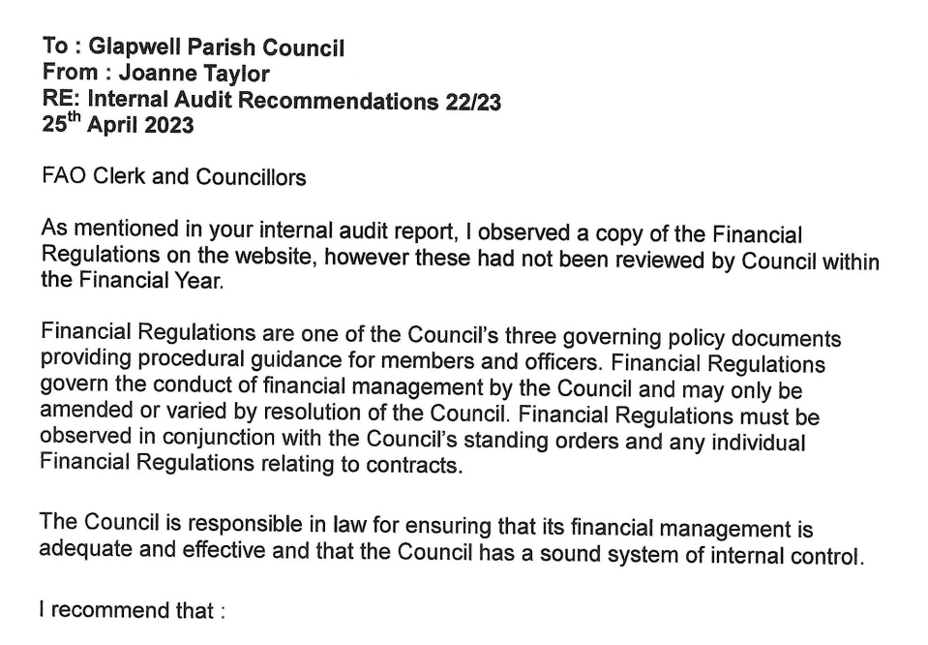
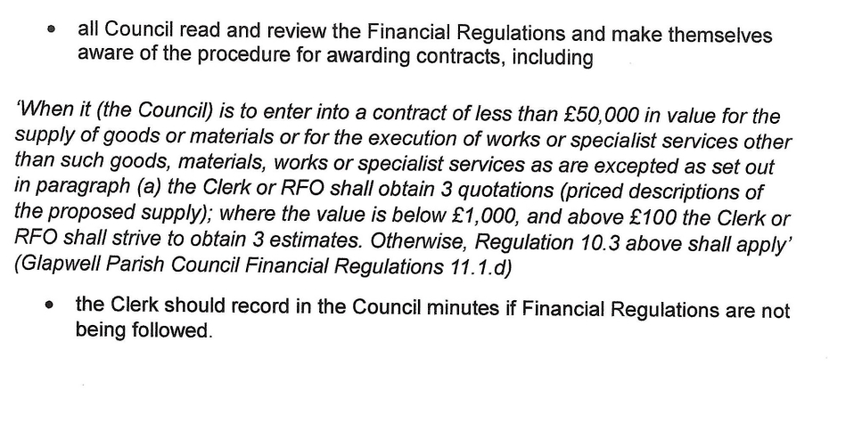

The Regulations require councils to use the Contracts Finder website if they advertise contract opportunities and also to publicise the award of contracts over £30,000 including VAT, regardless of whether they were advertised.

